AS Physics

Unit 2
Mechanics, Materials and Waves
1 Scalars and Vectors
2 Resolving Vectors
3 Moments
4 Velocity and Acceleration
5 Motion Graphs
6 Equations of Motion
7 Terminal Velocity and Projectiles
8 Newton’s Laws
9 Work, Energy and Power
10 Conservation of Energy
11 Hooke’s Law
12 Stress and Strain
13 Bulk Properties of Solids
14 Young’s Modulus
15 Progressive Waves
16 Longitudinal and Transverse Waves
17 Superposition and Standing Waves
18 Refraction
19 Total Internal Reflection
20 Interference
21 Diffraction

Unit 2 | Scalars and Vectors
Lesson 1
Learning Outcomes | To know the difference between scalars and vectors and be able to list some examples of each
Learning Outcomes | To be able to add vectors by scale drawing
Learning Outcomes | To be able to add negative vectors by scale drawing | N. DWYER

What is a Vector?
A vector is a physical quantity that has both magnitude (size) and direction.

Examples of Vectors: Displacement, velocity, force, acceleration and momentum.

What is a Scalar?
A scalar is a physical quantity that has magnitude only (it doesn’t act in a certain direction).

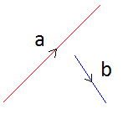
Examples of Scalars: Distance, speed, energy, power, pressure, temperature and mass.

Vector Diagrams
A vector can be represented by a vector diagram as well as numerically:
The length of the line represents the magnitude of the vector.
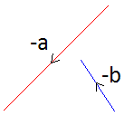
The direction of the line represents the direction of the vector.
We can see that vector a has a greater magnitude than vector b but acts in a different direction.
A negative vector means a vector of equal magnitude but opposite direction.

Adding Vectors
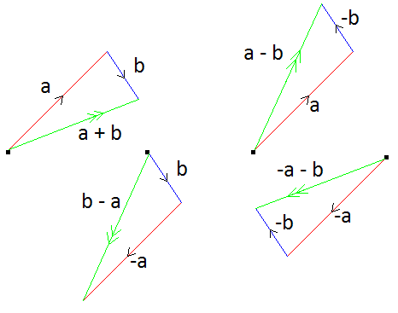
We can add vectors together to find the affect that two or more would have if acting at the same time. This is called the resultant vector. We can find the resultant vector in four ways: Scale drawing, Pythagoras, the Sine and Cosine rules and Resolving vectors (next lesson).

Scale Drawing
To find the resultant vector of a + b we draw vector a then draw vector b from the end of a. The resultant is the line that connects the start and finish points.
The resultants of a + b, b – a, a – b, – a – b and would look like this:

If the vectors were drawn to scale we can find the resultant by measuring the length of the line and the angle.

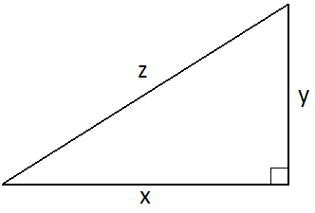
Pythagoras
If two vectors are perpendicular to each other the resultant can be found using Pythagoras:
Vector z is the resultant of vectors x and y.
Since x and y are perpendicular $z^{2}=x^{2}+y^{2}$ → $z=\sqrt{x^{2}+y^{2}}$
We can also use this in reverse to find x or y:
$z^{2}=x^{2}+y^{2}$ → $z^{2}−y^{2}=x^{2}$ → $\sqrt{z^{2}−y^{2}}=x$
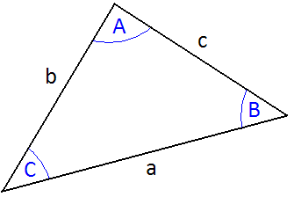
$z^{2}=x^{2}+y^{2}$ → $z^{2}−x^{2}=y^{2}$ → $\sqrt{z^{2}−x^{2}}=y$

Sine and Cosine Rules
The sine rule relates the angles and lengths using this equation:
$$\frac{\text{sin}A}{a}=\frac{\text{sin}B}{b}=\frac{\text{sin}C}{c}$$
The Cosine rule relates them using these equations:
$$a^{2}=b^{2}+c^{2}−2\text{bc}\text{cos}A$$
$$b^{2}=a^{2}+c^{2}−2\text{ac}\text{cos}B$$
$$c^{2}=a^{2}+b^{2}−2\text{ab}\text{cos}C$$
Unit 2 | Resolving Vectors
Lesson 2
Learning Outcomes | To be able to resolve vectors into their vertical and horizontal components
Learning Outcomes | To be able to add vectors and find the resultant by resolving them
Learning Outcomes | To know what equilibrium is and how it is achieved | N. DWYER

In the last lesson we looked at how we could add vectors together and find the resultant. In this lesson we will first look at ‘breaking down’ the vectors and then finding the equilibrium.

Resolving Vectors
A vector can be ‘broken down’ or resolved into its vertical and horizontal components.
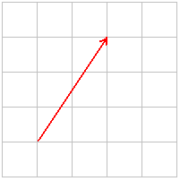
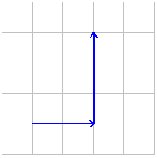
We can see that this vector can be resolved into two perpendicular components, in this case two to the right and three up.
This is obvious when it is drawn on graph paper but becomes trickier when there isn’t a grid and still requires an element of scale drawing.

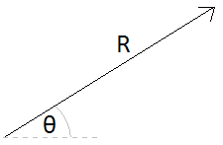
We can calculate the vertical and horizontal components if we know the magnitude and direction of the vector. In other words; we can work out the across and upwards bits of the vector if we know the length of the line and the angle between it and the horizontal or vertical axis.
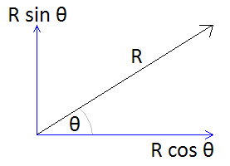

Adding Resolved Vectors
Now that we can resolve vectors into the vertical and horizontal components it is made from we can add them together. Look at this example of multiple vectors acting (A).
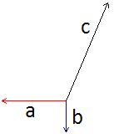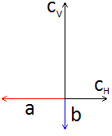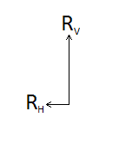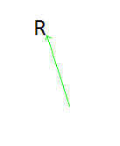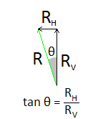
A B C D E
If we resolve the vector c we get (B). We can now find the resultant of the horizontal components and the resultant of the vertical components (C). We can then add these together to find the resultant vector (D) and the angle can be found using trigonometry (E)

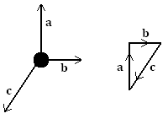
Equilibrium
When all the forces acting on a body cancel out equilibrium is reached and the object does not move. As you sit and read this the downwards forces acting on you are equally balanced by the upwards forces, the resultant it that you do not move.
With scale drawing we can draw the vectors, one after the other. If we end up in the same position we started at then equilibrium is achieved.
With resolving vectors we can resolve all vectors into their vertical and horizontal components. If the components up and down are equal and the components left and right are equal equilibrium has been reached.
Unit 2 | Moments
Lesson 3
Learning Outcomes | To be able to calculate the moment of a single and a pair of forces
Learning Outcomes | To be able to explain what the centre of mass and gravity are
Learning Outcomes | To be able to explain how something balances and becomes stable | N. DWYER

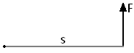
Moments (Also seen in GCSE Physics 3)
The moment of a force is its turning affect about a fixed point (pivot).
The magnitude of the moment is given by:
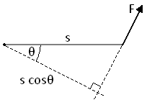
moment = force x perpendicular distance from force to the pivot
$\text{moment}=\text{Fs}$

In this diagram we can see that the force is not acting perpendicularly to the pivot. We must find the perpendicular or closest distance, this is s cosθ.
The moment in this case is given as: $\text{moment}=\text{Fs}\text{cos}θ$
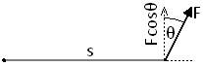
We could have also used the value of s but multiplied it by the vertical component of the force. This would give us the same equation. $\text{moment}=F\text{cos}θ\text{.}s$

Moments are measured in Newton metres, Nm

Couples
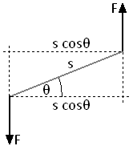
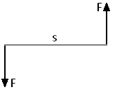
A couple is a pair of equal forces acting in opposite directions. If a couple acts on an object it rotates in position. The moment of a couple is called the torque.
The torque is calculated as: torque = force x perpendicular distance
between forces
$\text{torque}=\text{Fs}$
In the diagram to the right we need to calculate the perpendicular distance, s cosθ.
So in this case: $\text{torque}=\text{Fs}\text{cos}θ$

Torque is measured in Newton metres, Nm

Centre of Mass (Also seen in GCSE Physics 3)
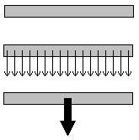
If we look at the ruler to the right, every part of it has a mass. To make tackling questions easier we can assume that all the mass is concentrated in a single point.

Centre of Gravity
The centre of gravity of an object is the point where all the weight of the object appears to act. It is in the same position as the centre of mass.
We can represent the weight of an object as a downward arrow acting from the centre of mass or gravity. This can also be called the line of action of the weight.

Balancing (Also seen in GCSE Physics 3)
When an object is balanced:
the total moments acting clockwise = the total moments acting anticlockwise
An object suspended from a point (e.g. a pin) will come to rest with the centre of mass directly below the point of suspension.
If the seesaw to the left is balanced then the clockwise moments must be equal to the anticlockwise moments.
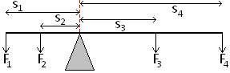
Clockwise moment due to 3 and 4
$\text{moment}=F_{3}s_{3}+F_{4}s_{4}$
Anticlockwise moments due to 1 and 2
$\text{moment}=F_{1}s_{1}+F_{2}s_{2}$
So $F_{3}s_{3}+F_{4}s_{4}=F_{1}s_{1}+F_{2}s_{2}$

Stability (Also seen in GCSE Physics 3)
The stability of an object can be increased by lowering the centre of mass and by widening the base.
An object will topple over if the line of action of the weight falls outside of the base.
Unit 2 | Velocity and Acceleration
Lesson 4
Learning Outcomes | To be able to calculate distance and displacement and explain what they are
Learning Outcomes | To be able to calculate speed and velocity and explain what they are
Learning Outcomes | To be able to calculate acceleration and explain uniform and non-uniform cases | N. DWYER

Distance (Also seen in Physics 2)
Distance is a scalar quantity. It is a measure of the total length you have moved.

Displacement (Also seen in Physics 2)
Displacement is a vector quantity. It is a measure of how far you are from the starting position.

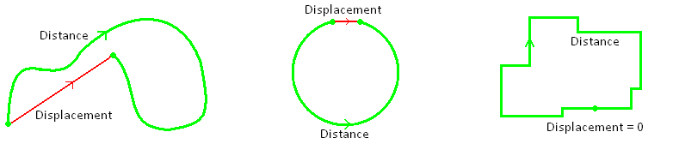
If you complete a lap of an athletics track: distance travelled = 400m
displacement = 0
Distance and Displacement are measured in metres, m

Speed (Also seen in Physics 2)
Speed is a measure of how the distance changes with time. Since it is dependent on speed it too is a scalar.
$$\text{speed}=\frac{Δd}{Δt}$$

Velocity (Also seen in Physics 2)
Velocity is measure of how the displacement changes with time. Since it depends on displacement it is a vector too.
$$v=\frac{Δs}{Δt}$$

Speed and Velocity are is measured in metres per second, m/s
Time is measured in seconds, s

Acceleration (Also seen in Physics 2)
Acceleration is the rate at which the velocity changes. Since velocity is a vector quantity, so is acceleration.
With all vectors, the direction is important. In questions we decide which direction is positive (e.g. → +ve)
If a moving object has a positive velocity: * a positive acceleration means an increase in the velocity
* a negative acceleration means a decrease in the velocity
(it begins the ‘speed up’ in the other direction)
If a moving object has a negative velocity: * a positive acceleration means an increase in the velocity
(it begins the ‘speed up’ in the other direction)
* a negative acceleration means a increase in the velocity
If an object accelerates from a velocity of u to a velocity of v, and it takes t seconds to do it then we can write the equations as $a=\frac{(v−u)}{t}$ it may also look like this $a=\frac{Δv}{Δt}$ where Δ means the ‘change in’

Acceleration is measured in metres per second squared, m/s²
Uniform Acceleration
In this situation the acceleration is constant – the velocity changes by the same amount each unit of time.
For example: If acceleration is 2m/s², this means the velocity increases by 2m/s every second.
Time (s) | 0 | 1 | 2 | 3 | 4 | 5 | 6 | 7
Velocity (m/s) | 0 | 2 | 4 | 6 | 8 | 10 | 12 | 14
Acceleration (m/s²) |  | 2 | 2 | 2 | 2 | 2 | 2 | 2
Non-Uniform Acceleration
In this situation the acceleration is changing – the velocity changes by a different amount each unit of time.
For example:
Time (s) | 0 | 1 | 2 | 3 | 4 | 5 | 6 | 7
Velocity (m/s) | 0 | 2 | 6 | 10 | 18 | 28 | 30 | 44
Acceleration (m/s²) |  | 2 | 4 | 6 | 8 | 10 | 12 | 14

Unit 2 | Motion Graphs
Lesson 5
Learning Outcomes | To be able to interpret displacement-time and velocity-time graphs
Learning Outcomes | To be able to represent motion with displacement-time and velocity-time graphs
Learning Outcomes | To know the significance of the gradient of a line and the area under it | N. DWYER

Before we look at the two types of graphs we use to represent motion, we must make sure we know how to calculate the gradient of a line and the area under it.

Gradient
$\text{gradient}=\frac{Δy}{Δx}$We calculate the gradient by choosing two points on the line and calculating the change in the y axis (up/down) and the change in the x axis (across).

Area Under Graph
At this level we will not be asked to calculate the area under curves, only straight lines.
We do this be breaking the area into rectangles (base x height) and triangles (½ base x height).

Displacement-Time Graphs (Also seen in GCSE Physics 2)
A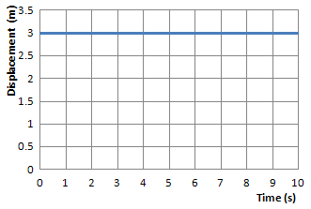 B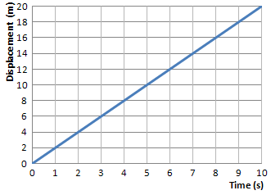 C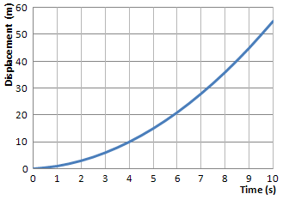
Graph A shows that the displacement stays at 3m, it is stationary.
Graph B shows that the displacement increases by the same amount each second, it is travelling with constant velocity.
Graph C shows that the displacement covered each second increases each second, it is accelerating.
Since $\text{gradient}=\frac{Δy}{Δx}$ and y = displacement and x = time → $\text{gradient}=\frac{Δs}{Δt}$ → $\text{gradient}=\text{velocity}$

Velocity- Time Graphs (Also seen in GCSE Physics 2)
A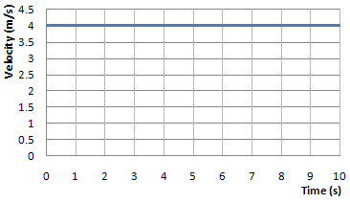 B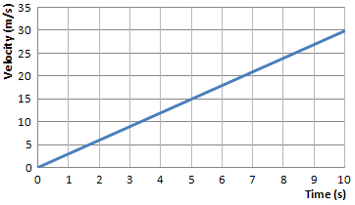 C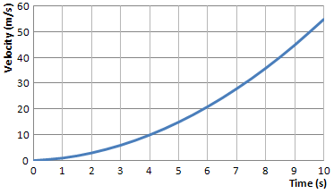
Graph A shows that the velocity stays at 4m/s, it is moving with constant velocity.
Graph B shows that the velocity increases by the same amount each second, it is accelerating by the same amount each second (uniform acceleration).
Graph C shows that the velocity increases by a larger amount each second, the acceleration is increasing (non-uniform acceleration).
Since $\text{gradient}=\frac{Δy}{Δx}$ and y = velocity and x = time → $\text{gradient}=\frac{Δv}{Δt}$ → $\text{gradient}=\text{acceleration}$
area = base x height → area = time x velocity → area = displacement

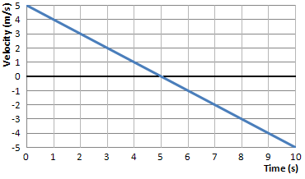
This graph show the velocity decreasing in one direction and increasing in the opposite direction.
If we decide that ←is negative and →is positive then the graph tells us:
The object is initially travels at 5 m/s →
It slows down by 1m/s every second
After 5 seconds the object has stopped
It then begins to move ←
It gains 1m/s every second until it is travelling at 5m/s ←
Unit 2 | Equations of Motion
Lesson 6
Learning Outcomes | To be able to use the four equations of motion
Learning Outcomes | To know the correct units to be used
Learning Outcomes | To be able to find the missing variable:, s u v a or t | N. DWYER

Defining Symbols
Before we look at the equations we need to assign letters to represent each variable
Displacement = s m metres
Initial Velocity = u m/s metres per second
Final Velocity = v m/s metres per second
Acceleration = a m/s² metres per second per second
Time = t s seconds

Equations of Motion
Equation 1
If we start with the equation for acceleration $a=\frac{(v−u)}{t}$ we can rearrange this to give us an equation 1
$\text{at}=(v−u)$ → $\text{at}+u=v$ $v=u+\text{at}$

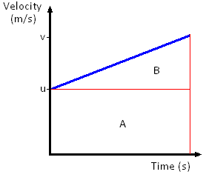
Equation 2
We start with the definition of velocity and rearrange for displacement
velocity = displacement / time → displacement = velocity x time

In situations like the graph to the right the velocity is constantly changing, we need to use the average velocity.
displacement = average velocity x time
The average velocity is give by: average velocity =$\frac{(u+v)}{2}$
We now substitute this into the equation above for displacement
displacement = $\frac{(u+v)}{2}$ x time → $s=\frac{(u+v)}{2}t$ $s=\frac{1}{2}(u+v)t$

Equation 3
With Equations 1 and 2 we can derive an equation which eliminated v. To do this we simply substitute $v=u+\text{at}$into $s=\frac{1}{2}(u+v)t$
$s=\frac{1}{2}(u+(u+\text{at}))t$ → $s=\frac{1}{2}(2u+\text{at})t$ → $s=\frac{1}{2}(2\text{ut}+{\text{at}}^{2})$ $s=\text{ut}+\frac{1}{2}{\text{at}}^{2}$

This can also be found if we remember that the area under a velocity-time graph represents the distance travelled/displacement. The area under the line equals the area of rectangle A + the area of triangle B.
Area = Displacement = s = $\text{ut}+\frac{1}{2}(v−u)t$ since $a=\frac{(v−u)}{t}$ then $\text{at}=(v−u)$ so the equation becomes $s=\text{ut}+\frac{1}{2}(\text{at})t$ which then becomes equation 3

Equation 4
If we rearrange equation 1 into $t=\frac{(v−u)}{a}$ which we will then substitute into equation 2:
$s=\frac{1}{2}(u+v)t$ → $s=\frac{1}{2}(u+v)\frac{(v−u)}{a}$ → $\text{as}=\frac{1}{2}(u+v)(v−u)$ →
$2\text{as}=(v^{2}+\text{uv}−\text{uv}−u^{2})$ → $2\text{as}=v^{2}−u^{2}$ $v^{2}=u^{2}+2\text{as}$

Any question can be solved as long as three of the variables are given in the question.
Write down all the variables you have and the one you are asked to find, then see which equation you can use.
These equations can only be used for motion with UNIFORM ACCELERATION.
Unit 2 | Terminal Velocity and Projectiles
Lesson 7
Learning Outcomes | To know what terminal velocity is and how it occurs
Learning Outcomes | To be know how vertical and horizontal motion are connected
Learning Outcomes | To be able to calculate the horizontal and vertical distance travelled by a projectile | N. DWYER

Acceleration Due To Gravity (Also seen in GCSE Physics 2)
An object that falls freely will accelerate towards the Earth because of the force of gravity acting on it.
The size of this acceleration does not depend mass, so a feather and a bowling ball accelerate at the same rate. On the Moon they hit the ground at the same time, on Earth the resistance of the air slows the feather more than the bowling ball.
The size of the gravitational field affects the magnitude of the acceleration. Near the surface of the Earth the gravitational field strength is 9.81 N/kg. This is also the acceleration a free falling object would have on Earth. In the equations of motion a = g = 9.81 m/s.
Mass is a property that tells us how much matter it is made of.
Mass is measured in kilograms, kg
Weight is a force caused by gravity acting on a mass:
weight = mass x gravitational field strength $w=\text{mg}$
Weight is measured in Newtons, N

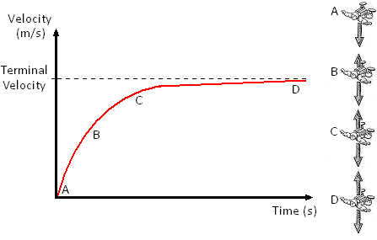
Terminal Velocity (Also seen in GCSE Physics 2)
If an object is pushed out of a plane it will accelerate towards the ground because of its weight (due to the Earth’s gravity). Its velocity will increase as it falls but as it does, so does the drag forces acting on the object (air resistance). Eventually the air resistance will balance the weight of the object. This means there will be no overall force which means there will be no acceleration. The object stops accelerating and has reached its terminal velocity.

Projectiles
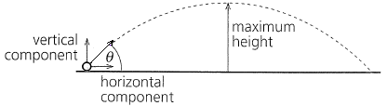
An object kicked or thrown into the air will follow a parabolic path like that shown to the right.
If the object had an initial velocity of u, this can be resolved into its horizontal and vertical velocity (as we have seen in Lesson 2)
The horizontal velocity will be ucosθ and the vertical velocity will be usinθ. With these we can solve projectile questions using the equations of motion we already know.

Horizontal and Vertical Motion
The diagram shows two balls that are released at the same time, one is released and the other has a horizontal velocity. We see that the ball shot from the cannon falls at the same rate at the ball that was released. This is because the horizontal and vertical components of motion are independent of each other.

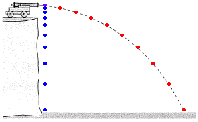
Horizontal: The horizontal velocity is constant; we see that the fired ball covers the same horizontal (across) distance with each second.
Vertical: The vertical velocity accelerates at a rate of g (9.81m/s²). We can see this more clearly in the released ball; it covers more distance each second.

The horizontal velocity has no affect on the vertical velocity. If a ball were fired from the cannon at a high horizontal velocity it would travel further but still take the same time to reach the ground.
Unit 2 | Newton’s Laws
Lesson 8
Learning Outcomes | To know and be able to use Newton’s 1st law of motion, where appropriate
Learning Outcomes | To know and be able to use Newton’s 2nd law of motion, where appropriate
Learning Outcomes | To know and be able to use Newton’s 3rd law of motion, where appropriate | N. DWYER

Newton’s 1st Law
An object will remain at rest, or continue to move with uniform velocity, unless it is acted upon by an external resultant force.

Newton’s 2nd Law
The rate of change of an object’s linear momentum is directly proportional to the resultant external force. The change in the momentum takes place in the direction of the force.

Newton’s 3rd Law
When body A exerts a force on body B, body B exerts an equal but opposite force on body A.
Force is measured in Newtons, N
Say What?
Newton’s 1st Law
If the forward and backward forces cancel out, a stationary object will remain stationary.
If the forward forces are greater than the backwards forces, a stationary object will begin to move forwards.
If the forward and backward forces cancel out, a moving object will continue to move with constant velocity.
If the forward forces are greater than the backward forces, a moving object will speed up.
If the backward forces are greater than the forward forces, a moving object will slow down.
Newton’s 2nd Law
The acceleration of an object increases when the force is increased but decreases when the mass is increased: $a=\frac{F}{m}$ but we rearrange this and use $F=\text{ma}$
Newton’s 3rd Law
Forces are created in pairs.
As you sit on the chair your weight pushes down on the chair, the chair also pushes up against you.
As the chair rests on the floor its weight pushes down on the floor, the floor also pushes up against the chair.
The forces have the same size but opposite directions.

Riding the Bus
Newton’s 1st Law
You get on a bus and stand up. When the bus is stationary you feel no force, when the bus accelerates you feel a backwards force. You want to stay where you are but the bus forces you to move. When the bus is at a constant speed you feel no forwards or backwards forces. The bus slows down and you feel a forwards force. You want to keep moving at the same speed but the bus is slowing down so you fall forwards. If the bus turns left you want to keep moving in a straight line so you are forced to the right (in comparison to the bus). If the bus turns right you want to keep moving in a straight line so you are forced left (in comparison to the bus).
Newton’s 2nd Law
As more people get on the bus its mass increases, if the driving force of the bus’s engine is constant we can see that it takes longer for the bus to gain speed.
Newton’s 3rd Law
As you stand on the bus you are pushing down on the floor with a force that is equal to your weight. If this was the only force acting you would begin to move through the floor. The floor is exerting a force of equal magnitude but upwards (in the opposite direction).

Taking the Lift
Newton’s 1st Law
When you get in the lift and when it moves at a constant speed you feel no force up or down. When it sets off going up you feel like you are pushed down, you want to stay where you are. When it sets off going down you feel like you are lighter, you feel pulled up.
Newton’s 2nd Law
As more people get in the lift its mass increases, if the lifting force is constant we can see that it takes longer for the lift to get moving. Or we can see that with more people the greater the lifting force must be.
Newton’s 3rd Law
As you stand in the lift you push down on the floor, the floor pushes back.
Unit 2 | Work, Energy and Power
Lesson 9
Learning Outcomes | To be able to calculate work done (including situations involving an inclined plane)
Learning Outcomes | To be able to calculate the power of a device
Learning Outcomes | To be able to calculate efficiency and percentage efficiency | N. DWYER

Energy (Also seen in GCSE Physics 1)
We already know that it appears in a number of different forms and may be transformed from one form to another. But what is energy? Energy is the ability to do work.
We can say that the work done is equal to the energy transferred
Work done = energy transferred $W=E$

Work Done (Also seen in GCSE Physics 2)
In Physics we say that work is done when a force moves through a distance and established the equation
Work Done = Force x Distance moved in the direction of the force $W=\text{Fs}$
Work Done is measured in Joules, J
Force is measured in Newtons, N
Distance is measured in metres, m
The distance moved is not always in the direction of the force. In the diagram we can see that the block moves in a direction that is θ away from the ‘line of action’ of the force. To calculate the work done we must calculate the distance we move in the direction of the force or the size of the force in the direction of the distance moved. Both of these are calculated by resolving into horizontal and vertical components.
Work Done = Force x Distance moved in the direction of the force
Work Done = Size of Force in the direction of movement x Distance moved
Work Done = $\text{Fs}\text{cos}θ$
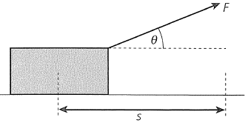 → 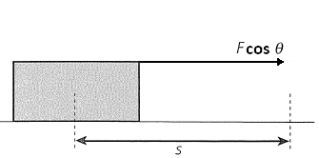 or 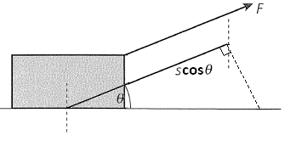

Power (Also seen in GCSE Physics 1 and AS Unit 1)
Power is a measure of how quickly something can transfer energy. Power is linked to energy by the equation:

$\text{Power}=\frac{\text{EnergyTransferred}}{\text{timetaken}}$$P=\frac{ΔE}{Δt}$

Power is measured in Watts, W
Energy is measured in Joules, J
Time is measured in seconds, s

But Work Done = Energy Transferred so we can say that power is a measure of how quickly work can be done.
$\text{Power}=\frac{\text{WorkDone}}{\text{timetaken}}$ $P=\frac{ΔW}{Δt}$
Now that we can calculate Work Done we can derive another equation for calculating power:
We can substitute $W=\text{Fs}$ into $P=\frac{W}{t}$ to become $P=\frac{\text{Fs}}{t}$this can be separated into$P=F\frac{s}{t}$ .
$\frac{s}{t}=v$so we can write $P=\text{Fv}$
Velocity is measured in metres per second, m/s or ms⁻¹

Efficiency (Also seen in GCSE Physics 1)
We already know that the efficiency of a device is a measure of how much of the energy we put in is wasted.
Efficiency = useful energy transferred by the device this will give us a number less than 1
total energy supplied to the device
Useful energy means the energy transferred for a purpose, the energy transferred into the desired form.
Since power is calculated from energy we can express efficiency as:
Efficiency = useful output power of the device again this will give us a number less than 1
input power to the device
To calculate the efficiency as a percentage use the following:
percentage efficiency = efficiency x 100%
Unit 2 | Conservation of Energy
Lesson 10
Learning Outcomes | To be able to calculate gravitational potential energy
Learning Outcomes | To be able to calculate kinetic energy
Learning Outcomes | To be able to solve problems involving the conversion of energy | N. DWYER

Energy Transformations (Also seen in GCSE Physics 1)
We already know that energy cannot be created or destroyed, only transformed from one type to another and transferred from one thing to another. Eg a speaker transforms electrical energy to sound energy with the energy itself is being transferred to the surroundings.
An isolated (or closed) system means an energy transformation is occurring where none of the energy is lost to the surroundings. In reality all transformations/transfers are not isolated, and all of them waste energy to the surroundings.

Kinetic Energy (Also seen in GCSE Physics 2)
Kinetic energy is the energy a moving object has. Let us consider a car that accelerates from being stationary (u=0) to travelling at a velocity v when a force, F, is applied.
The time it takes to reach this velocity is give by $v=u+\text{at}$ → $v=\text{at}$ → $t=\frac{v}{a}$
The distance moved in this time is given by$s=\frac{1}{2}(u+v)t$ → $s=\frac{1}{2}(v)t$ → $s=\frac{1}{2}(v)\frac{v}{a}$ → $s=\frac{1}{2}\frac{v^{2}}{a}$
Energy transferred = Work Done, Work Done = Force x distance moved and Force = mass x acceleration
$E=W$ → $E=\text{Fs}$ → $E=\text{mas}$ → $E=\text{ma}\frac{1}{2}\frac{v^{2}}{a}$ $E_{K}=\frac{1}{2}{\text{mv}}^{2}$
Velocity is measured in metres per second, m/s
Mass is measured in kilograms, kg
Kinetic Energy is measured in Joules, J

Gravitational Potential Energy
This type of potential (stored) energy is due to the position of an object. If an object of mass m is lifted at a constant speed by a height of h we can say that the acceleration is zero. Since F=ma we can also say that the overall force is zero, this means that the lifting force is equal to the weight of the object → F=mg
We can now calculate the work done in lifting the object through a height, h.
$\text{WD}=\text{Fs}$ → $\text{WD}=(\text{mg})h$ → $\text{WD}=\text{mgh}$
Since work done = energy transferred ${ΔE}_{P}=\text{mg}Δh$
Height is a measure of distance which is measured in metres, m
Gravitational Potential Energy is measured in Joules, J

Work Done against….
In many situations gravitational potential energy is converted into kinetic energy, or vice versa. Some everyday examples of this are:
Swings and pendulums If we pull a pendulum back we give it GPE, when it is released it falls, losing its GPE but speeding up and gaining KE. When it passes the lowest point of the swing it begins to rise (gaining GPE) and slow down (losing KE).
Bouncing or throwing a ball Holding a ball in the air gives it GPE, when we release this it transforms this into KE. As it rises it loses KE and gains GPE.
Slides and ramps A ball at the top of a slide will have GPE. When it reaches the bottom of the slide it has lost all its GPE, but gained KE.

In each of these cases it appears as though we have lost energy. The pendulum doesn’t swing back to its original height and the ball never bounces to the height it was released from. This is because work is being done against resistive forces.
The swing has to overcome air resistance whilst moving and the friction from the top support.
The ball transforms some energy into sound and overcoming the air resistance.
Travelling down a slide transforms energy into heat due to friction and air resistance

The total energy before a transformation = The total energy after a transformation
Unit 2 | Hooke’s Law
Lesson 11
Learning Outcomes | To be able to state Hooke’s Law and explain what the spring constant is
Learning Outcomes | To be able to describe how springs behave in series and parallel
Learning Outcomes | To be able to derive the energy stored in a stretched material | N. DWYER

Hooke’s Law
If we take a metal wire or a spring and hang it from the ceiling it will have a natural, unstretched length of l metres. If we then attach masses to the bottom of the wire is will begin to increase in length (stretch). The amount of length it has increased by we will call the extension and represent by e.
If the extension increases proportionally to the force applied it follows Hooke’s Law:
The force needed to stretch a spring is directly proportional to the extension of the spring from its natural length
So it takes twice as much force to extend a spring twice as far and half the force to extend it half as far.
We can write this in equation form: $F∝e$ or $F=\text{ke}$
Here k is the constant that shows us how much extension in length we would get for a given force. It is called...
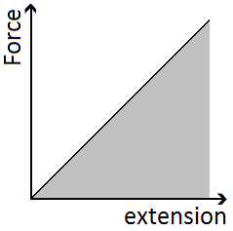

The Spring Constant
The spring constant gives us an idea of the stiffness (or stretchiness) of the material.
If we rearrange Hooke’s Law we get:$k=\frac{F}{e}$
If we record the length of a spring, add masses to the bottom and measure its extension we can plot a graph of force against extension. The gradient of this graph will be equal to the spring constant.
A small force causes a large extension the spring constant will be small – very stretchy
A large force causes a small extension the spring constant will be large – not stretchy
Spring Constant is measured in Newtons per metre, N/m

Springs in Series
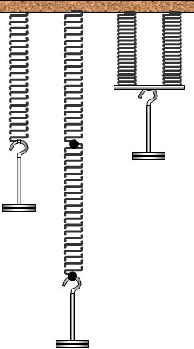
The combined spring constant of spring A and spring B connected in series is given by:
$\frac{1}{k_{T}}=\frac{1}{k_{A}}+\frac{1}{k_{B}}$ If A and B are identical this becomes:
$\frac{1}{k_{T}}=\frac{1}{k}+\frac{1}{k}$ → $\frac{1}{k_{T}}=\frac{2}{k}$ → $k_{T}=\frac{k}{2}$
Since this gives us a smaller value for the spring constant, applying the same force produces a larger extension. It is stretchier

Springs in Parallel
The combined spring constant of spring A and spring B connected in parallel is:
$k_{T}=k_{A}+k_{B}$ so if A and B are identical this becomes:
$k_{T}=k+k$ → $k_{T}=2k$
Since this gives us a larger value for the spring constant applying the same force produces a smaller extension. It is less stretchy

Energy Stored (Elastic Strain Energy)
We can calculate the energy stored in a stretched material by considering the work done on it.
We defined work done as the force x distance moved in the direction of the force or $W=\text{Fs}$
Work done is equal to the energy transferred, in this case transferred to the material, so: $E=\text{Fs}$
The distance moved is the extension of the material, e, making the equation: $E=\text{Fe}$
The force is not constant; it increases from zero to a maximum of F. The average force is given by: $\frac{(F−0)}{2}$
If we bring these terms together we get the equation$E=\frac{(F−0)}{2}e$ which simplifies to: $E=\frac{1}{2}\text{Fe}$
This is also equal to the area under the graph of force against extension.
We can write a second version of this equation by substituting our top equation of $F=\text{ke}$ into the one above.
$E=\frac{1}{2}\text{Fe}$ → $E=\frac{1}{2}(\text{ke})e$ → $E=\frac{1}{2}{\text{ke}}^{2}$
Unit 2 | Stress and Strain
Lesson 12
Learning Outcomes | To know what stress is, be able to explain it, calculate it and state its units
Learning Outcomes | To know what strain is, be able to explain it, calculate it and state its units
Learning Outcomes | To be able to calculate the elastic strain energy per unit volume | N. DWYER

Deforming Solids
Forces can be used to change the speed, direction and shape of an object. This section of Physics looks at using forces to change of shape of a solid object, either temporarily or permanently.
If a pair of forces are used to squash a material we say that they are compressive forces.
If a pair of forces is used to stretch a material we say that they are tensile forces.

Tensile Stress, σ
Tensile stress is defined as the force applied per unit cross-sectional area (which is the same as pressure).
This is represented by the equations:
$\text{stress}=\frac{F}{A}$ $σ=\frac{F}{A}$
The largest tensile stress that can be applied to a material before it breaks is called the ultimate tensile stress (UTS). Nylon has an UTS of 85 MPa whilst Stainless steel has a value of 600 MPa and Kevlar a massive 3100 MPa
Stress is measured in Newtons per metre squared, N/m² or N m⁻²
Stress can also be measured in Pascals, Pa
A tensile stress will cause a tensile strain. Stress causes Strain

Tensile Strain, ε
Tensile strain is a measure of how the extension of a material compares to the original, unstretched length.
This is represented by the equations:
$\text{strain}=\frac{e}{l}$ $ε=\frac{e}{l}$
Steel wire will undergo a strain of 0.01 before it breaks. This means it will stretch by 1% of its original length then break. Spider silk has a breaking strain of between 0.15 and 0.30, stretching by 30% before breaking
Strain has no units, it is a ratio of two lengths

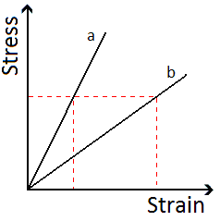
Stress-Strain Graphs
A stress-strain graph is very useful for comparing different materials.
Here we can see how the strain of two materials, a and b, changes when a stress is applied.
If we look at the dotted lines we can see that the same amount of stress causes a bigger strain in b than in a. This means that b will increase in length more than a (compared to their original lengths).

Elastic Strain Energy
We can build on the idea of energy stored from the previous lesson now that we know what stress and strain are. We can work out the amount of elastic strain energy that is stored per unit volume of the material.
It is given by the equation: $E=\frac{1}{2}\text{stress}×\text{strain}$
There are two routes we can take to arrive at this result:
Equations
If we start with the equation for the total energy stored in the material: $E=\frac{1}{2}\text{Fe}$
The volume of the material is given by: $V=\text{Al}$
Now divide the total energy stored by the volume: $E=\frac{\frac{1}{2}\text{Fe}}{\text{Al}}$ which can be written as: $E=\frac{1}{2}\frac{F}{A}\frac{e}{l}$
If we compare the equation to the equations we know for stress and strain we see that: $E=\frac{1}{2}\text{stress}×\text{strain}$
Graphs
The area under a stress-strain graph gives us the elastic strain energy per unit volume (m³). The area is given by:
$A=\frac{1}{2}\text{base}×\text{height}$ → $A=\frac{1}{2}\text{strain}×\text{stress}$ or $A=\frac{1}{2}\text{stress}×\text{strain}$ → $E=\frac{1}{2}\text{stress}×\text{strain}$
Unit 2 | Bulk Properties of Solids
Lesson 13
Learning Outcomes | To be able to calculate density and explain what it is
Learning Outcomes | To be able to explain what elastic, plastic, yield point, breaking stress, stiff, ductile and brittle are
Learning Outcomes | To be able to label these qualities on stress-strain graphs | N. DWYER

Density, ρ
$ρ=\frac{m}{V}$Density is the mass per unit volume of a material, a measure of how much mass each cubic metre of volume contains. Density if given by the equation:
Where ρ is density, m is mass in kilograms and V is volume in metres cubed.
Density is measured in kilograms per metre cubed, kg/m³ or kg m⁻³

Elasticity
Materials extend in length when a stress is applied to them (masses hung from them). A material can be described as elastic if it returns to its original length when the stress is removed. They obey Hooke’s Law as extension is proportional to the force applied.

Limit of Proportionality, P
Up to this point the material obeys Hooke’s Law; extension is proportional to the force applied.

Elastic Limit, E
The elastic limit is the final point where the material will return to its original length if we remove the stress which is causing the extension (take the masses off). There is no change to the shape or size of the material.
We say that the material acts plastically beyond its elastic limit.

Yield Point, Y
Beyond the elastic limit a point is reached where small increases in stress cause a massive increase in extension (strain). The material will not return to its original length and behaves like a plastic.

Plasticity
Materials extend in length when a stress is applied to them (masses hung from them). A material can be described as plastic if it does not return to its original length when the stress is removed. There is a permanent change to its shape

Breaking Stress – Ultimate Tensile Strength, UTS
This is the maximum amount of stress that can be applied to the material without making it break. It is sometimes referred to as the strength of the material.

Breaking Point, B
This is (surprisingly?) the point where the material breaks.

Stiffness
If different materials were made into wires of equal dimensions, the stiffer materials bend the least.
Stiff materials have low flexibility

Ductility
A ductile material can be easily and permanently stretched. Copper is a good example, it can easily be drawn out into thin wires. This can be seen in graph d below.

Brittleness
A brittle material will extend obeying Hooke’s Law when a stress is applied to it. It will suddenly fracture with no warning sign of plastic deformation. Glass, pottery and chocolate are examples of brittle materials.

Stress-Strain Graphs
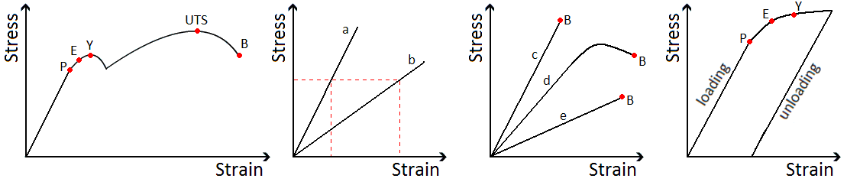
In the first graph we see a material that stretches, shows plastic behaviour and eventually breaks.
In the second graph we can see that material a is stiffer than material b because the same stress causes a greater strain in b.
In the third graph we see materials c and e are brittle because they break without showing plastic behaviour.
The fourth graph shows how a material can be permanently deformed, the wire does not return to its original length when the stress is removed (the masses have been removed).
Unit 2 | The Young Modulus
Lesson 14
Learning Outcomes | To know what the Young Modulus is, be able to explain it, calculate it and state its units
Learning Outcomes | To be able to describe an experiment for finding the Young Modulus
Learning Outcomes | To be able to calculate the Young Modulus from a stress-strain graph | N. DWYER

The Young Modulus, E
The Young Modulus can be thought of as the stiffness constant of a material, a measure of how much strain will result from a stress being applied to the material. It can be used to compare the stiffness of different materials even though their dimensions are not the same.
The Young Modulus only applies up to the limit of proportionality of a material.
$\text{YoungModulus}=\frac{\text{stress}}{\text{strain}}$ or in equation terms we have $E=\frac{σ}{ε}$
We have equations for stress $σ=\frac{F}{A}$ and strain $ε=\frac{e}{l}$ which makes the equation look like this: $E=\frac{\left(\frac{F}{A}\right)}{\left(\frac{e}{l}\right)}$
An easier way of writing this is $E=\left(\frac{F}{A}\right)×\left(\frac{l}{e}\right)$ which becomes: $E=\frac{\text{Fl}}{\text{Ae}}$
The Young Modulus is measured in Newtons per metre squares, N/m² or N m⁻²

Stress-Strain Graphs
The Young Modulus of a material can be found from its stress-strain graph.
Since$\text{gradient}=\frac{Δy}{Δx}$, this becomes $\text{gradient}=\frac{\text{stress}}{\text{strain}}$ for our graph. Our top equation stated that $\text{YoungModulus}=\frac{\text{stress}}{\text{strain}}$ so we see that the gradient of a stress-strain graph gives us the Young Modulus.
This only applied to the straight line section of the graph, where gradient (and Young Modulus) are constant.

Measuring the Young Modulus
Here is a simple experimental set up for finding the Young Modulus of a material.
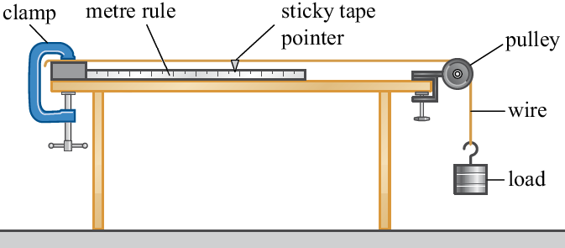
- A piece of wire is held by a G-clamp, sent over a pulley with the smallest mass attached to it. This should keep it straight without extending it.
- Measure the length from the clamp to the pointer. This is the original length (unstretched).
- Use a micrometer to measure the diameter of the wire in several places. Use this to calculate the cross-sectional area of the wire.
- Add a mass to the loaded end of the wire.
- Record the extension by measuring how far the pointer has moved from its start position.
- Repeat for several masses but ensuring the elastic limit is not reached.
- Remove the masses, one at a time taking another set of reading of the extension.
- Calculate stress and strain for each mass.
- Plot a graph of stress against strain and calculate the gradient of the line which gives the Young Modulus.

Here is a more precise way of finding the Young Modulus but involves taking the same measurements of extension and force applied.
It is called Searle’s apparatus.
Unit 2 | Progressive Waves
Lesson 15
Learning Outcomes | To be know the basic measurements of a wave
Learning Outcomes | To be able to calculate the speed of any wave
Learning Outcomes | To be know what phase and path difference are and be able to calculate them | N. DWYER

Waves
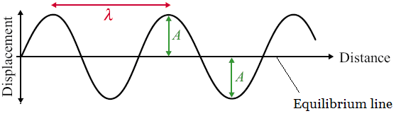
All waves are caused by oscillations and all transfer energy without transferring matter. This means that a water wave can transfer energy to you sitting on the shore without the water particles far out to sea moving to the beach.
Here is a diagram of a wave; it is one type of wave called a transverse wave. A wave consists of something (usually particles) oscillating from an equilibrium point. The wave can be described as progressive; this means it is moving outwards from the source.
We will now look at some basic measurements and characteristics or waves.

Amplitude, A Amplitude is measured in metres, m
The amplitude of a wave is the maximum displacement of the particles from the equilibrium position.

Wavelength, λ Wavelength is measured in metres, m
The wavelength of a wave is the length of one whole cycle. It can be measured between two adjacent peaks, troughs or any point on a wave and the same point one wave later.

Time Period, T Time Period is measured in seconds, s
This is simply the time is takes for one complete wave to happen. Like wavelength it can be measured as the time it takes between two adjacent peaks, troughs or to get back to the same point on the wave.

Frequency, f Frequency is measured in Hertz, Hz
Frequency is a measure of how often something happens, in this case how many complete waves occur in every second. It is linked to time period of the wave by the following equations: $T=\frac{1}{f}$ and $f=\frac{1}{T}$

Wave Speed, c Wave Speed is measured in metres per second, m s⁻¹
The speed of a wave can be calculated using the following equations: $c=fλ$
Here c represents the speed of the wave, f the frequency and λ the wavelength.

Phase Difference Phase Difference is measured in radians, rad
If we look at two particles a wavelength apart (such as C and G) we would see that they are oscillating in time with each other. We say that they are completely in phase. Two points half a wavelength apart (such as I and K) we would see that they are always moving in opposite directions. We say that they are completely out of phase.
The phase difference between two points depends on what fraction of a wavelength lies between them
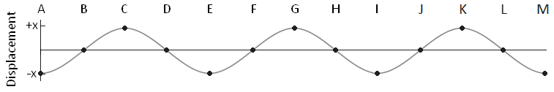
 | B | C | D | E | F | G | H | I | J | K | L | M
Phase Difference  from A (radians) | ½π | 1π | 1½π | 2π | 2½π | 3π | 3½π | 4π | 4½π | 5π | 5½π | 6π
Phase Difference  from A (degrees) | 90 | 180 | 270 | 360 | 450 | 540 | 630 | 720 | 810 | 900 | 990 | 1080

Path Difference Path Difference is measured in wavelengths, λ
If two light waves leave a bulb and hit a screen the difference in how far the waves have travelled is called the path difference. Path difference is measured in terms of wavelengths.
 | B | C | D | E | F | G | H | I | J | K | L | M
Path Difference  from A | ¼λ | ½λ | ¾λ | 1λ | 1¼λ | 1½λ | 1¾λ | 2λ | 2¼λ | 2½λ | 2¾λ | 3λ
So two waves leaving A with one making it to F and the other to J will have a path difference of 1 wavelength (1λ).
Unit 2 | Longitudinal and Transverse Waves
Lesson 16
Learning Outcomes | To be able explain the differences between longitudinal and transverse waves
Learning Outcomes | To know examples of each
Learning Outcomes | To be explain what polarisation is and how it proves light is a transverse wave | N. DWYER

Waves
All waves are caused by oscillations and all transfer energy without transferring matter. This means that a sound wave can transfer energy to your eardrum from a far speaker without the air particles by the speaker moving into your ear. We will now look at the two types of waves and how they are different

Longitudinal Waves
Here is a longitudinal wave; the oscillations are parallel to the direction of propagation (travel).
Where the particles are close together we call a compression and where they are spread we call a rarefaction.
The wavelength is the distance from one compression or rarefaction to the next.
The amplitude is the maximum distance the particle moves from its equilibrium position to the right of left.
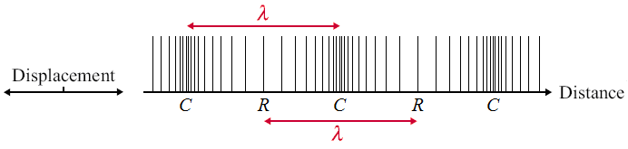

Example:
sound waves

Transverse Waves
Here is a transverse wave; the oscillations are perpendicular to the direction of propagation.
Where the particles are displaced above the equilibrium position we call a peak and below we call a trough.
The wavelength is the distance from one peak or trough to the next.
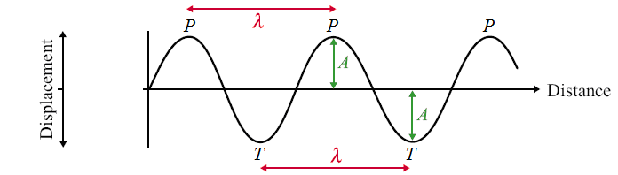
The amplitude is the maximum distance the particle moves from its equilibrium position up or down.

Examples: water waves,
Mexican waves and
waves of the EM spectrum
EM waves are produced from varying electric and magnetic field.

Polarisation
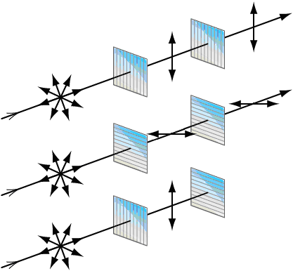
Polarisation restricts the oscillations of a wave to one plane. In the diagrams the light is initially oscillating in all directions. A piece of Polaroid only allows light to oscillate in the same direction as it.
- In the top diagram the light passes through a vertical plane Polaroid and becomes polarized in the vertical plane. This can then pass through the second vertical Polaroid.
- In the middle diagram the light becomes polarized in the horizontal plane.
- In the bottom diagram the light becomes vertically polarized but this cannot pass through a horizontal plane Polaroid.
This is proof that the waves of the EM spectrum are transverse waves. If they were longitudinal waves the forwards and backwards motion would not be stopped by crossed pieces of Polaroid; the bottom set up would emit light.

Applications
TV aerials get the best reception when they point to the transmission source so they absorb the maximum amount of the radio waves.
Unit 2 | Superposition and Standing Waves
Lesson 17
Learning Outcomes | To know and be able to explain what standing waves are and how they are formed
Learning Outcomes | To know what nodes and antinodes are
Learning Outcomes | To be able to sketch the standing wave produced at different frequencies | N. DWYER

Superposition
Here are two waves that have amplitudes of 1.0 travelling in opposite directions:
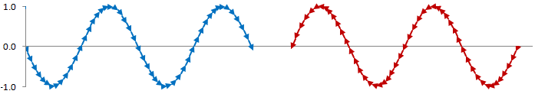
Superposition is the process by which two waves combine into a single wave form when they overlap.
If we add these waves together the resultant depends on where the peaks of the waves are compared to each other. Here are three examples of what the resultant could be: a wave with an amplitude of 1.5, no resultant wave at all and a wave with an amplitude of 2.0
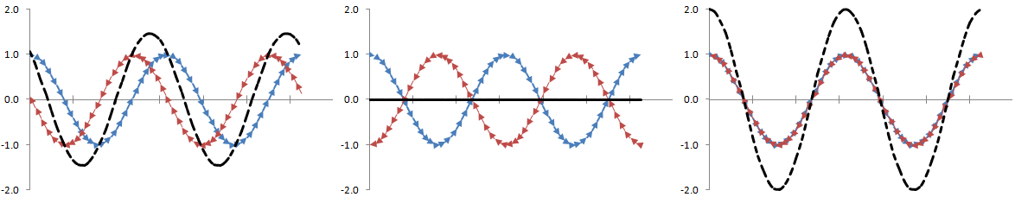

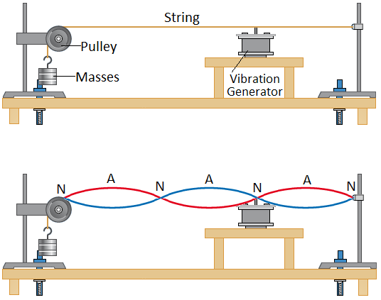
Stationary/Standing Waves
When two similar waves travel in opposite directions they can superpose to form a standing (or stationary) wave. Here is the experimental set up of how we can form a standing wave on a string. The vibration generator sends waves down the string at a certain frequency, they reach the end of the string and reflect back at the same frequency. On their way back the two waves travelling in opposite direction superpose to form a standing wave made up of nodes and antinodes.

Nodes Positions on a standing wave which do not vibrate. The waves combine to give zero displacement

Antinodes Positions on a standing wave where there is a maximum displacement.

 | Standing Waves | Progressive Waves
Amplitude | Maximum at antinode and zero at nodes | The same for all parts of the wave
Frequency | All parts of the wave have the same frequency | All parts of the wave have the same frequency
Wavelength | Twice the distance between adjacent nodes | The distance between two adjacent peaks
Phase | All points between two adjacent nodes in phase | Points one wavelength apart in phase
Energy | No energy translation | Energy translation in the direction of the wave
Waveform | Does not move forward | Moves forwards

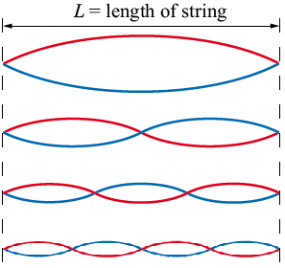
Harmonics
As we increase the frequency of the vibration generator we will see standing waves being set up. The first will occur when the generator is vibrating at the fundamental frequency, f₀, of the string.

First Harmonic f = f₀ λ = 2 L
2 nodes and 1 antinode

Second Harmonic f = 2f₀ λ = L
3 nodes and 2 antinodes

Third Harmonic f = 3f₀ λ = ⅔ L
4 nodes and 3 antinodes

Forth Harmonic f = 4f₀ λ = ½ L
5 nodes and 4 antinodes
Unit 2 | Refraction
Lesson 18
Learning Outcomes | To be able to calculate the refractive index of a material and to know what it tells us
Learning Outcomes | To be able to describe and explain the direction light takes when entering a different material
Learning Outcomes | To be able to calculate the relative refractive index of a boundary | N. DWYER

Refractive Index
The refractive index of a material is a measure of how easy it is for light to travel through it. The refractive index of material s can be calculated using:
$n=\frac{c}{c_{s}}$
where n is the refractive index, c is the speed of light in a vacuum and c_{s} is the speed of light in material s.
Refractive Index, n, has no units
If light can travel at c in material x then the refractive index is: $n=\frac{c}{c_{x}}$ → $n=\frac{c}{c}$ → $n=1$
If light can travel at c/2 in material y then the refractive index is: $n=\frac{c}{c_{y}}$ → $n=\frac{c}{c2}$ → $n=2$
The higher the refractive index the slower light can travel through it
The higher the refractive index the denser the material

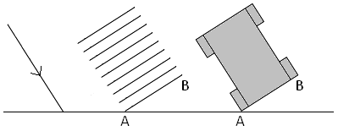
Bending Light
When light passes from one material to another it is not only the speed of the light that changes, the direction can change too.
If the ray of light is incident at 90° to the material then there is no change in direction, only speed.
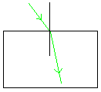
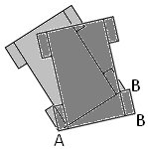
It may help to imagine the front of the ray of light as the front of a car to determine the direction the light will bend. Imagine a lower refractive index as grass and a higher refractive index at mud.
Entering a Denser Material
The car travels on grass until tyre A reaches the mud. It is harder to move through mud so A slows down but B can keep moving at the same speed as before. The car now points in a new direction.
Denser material – higher refractive index – bends towards the Normal
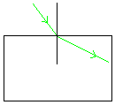
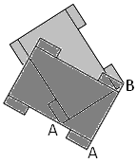
Entering a Less Dense Material
The car travels in mud until tyre A reaches the grass. It is easier to move across grass so A can speed up but B keeps moving at the same speed as before. The car now points in a new direction.
Less dense material – lower refractive index – bends away from the Normal

Relative Refractive Index
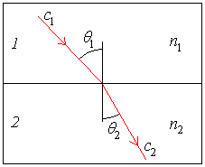
Whenever two materials touch the boundary between them will have a refractive index dependent on the refractive indices of the two materials. We call this the relative refractive index.
When light travels from material 1 to material 2 we can calculate the relative refractive index of the boundary using any of the following:
$$n_{2}=\frac{n_{2}}{n_{1}}=\frac{c_{1}}{c_{2}}=\frac{\text{sin}θ_{1}}{\text{sin}θ_{2}}$$
Relative Refractive Index, ₁n₂, has no units
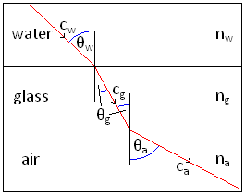
Some questions may involve light travelling through several layers of materials. Tackle one boundary at a time.
$n_{g}=\frac{n_{g}}{n_{w}}=\frac{c_{w}}{c_{g}}=\frac{\text{sin}θ_{w}}{\text{sin}θ_{g}}$ ---------------------------->
$n_{a}=\frac{n_{a}}{n_{g}}=\frac{c_{g}}{c_{a}}=\frac{\text{sin}θ_{g}}{\text{sin}θ_{a}}$ ---------------------------->
Unit 2 | Total Internal Reflection
Lesson 19
Learning Outcomes | To know what the critical angle is and be able to calculate it
Learning Outcomes | To be able to explain what fibre optics are and how they are used
Learning Outcomes | To be able to explain how cladding helps improve the efficiency of a fibre optic | N. DWYER

Total Internal Reflection (Also seen in GCSE Physics 3)
We know that whenever light travels from one material to another the majority of the light refracts but a small proportion of the light also reflects off the boundary and stays in the first material.
When the incident ray strikes the boundary at an angle less than the critical angle the light refracts into the second material.
When the incident ray strikes the boundary at an angle equal to the critical angle all the light is sent along the boundary between the two materials.
When the incident ray strikes the boundary at an angle greater than the critical angle all the light is reflected and none refracts, we say it is total internal reflection has occurred.
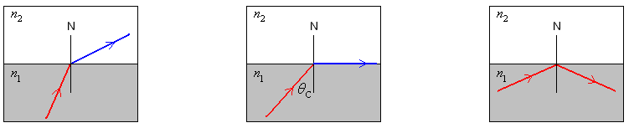

Critical Angle (Also seen in GCSE Physics 3)
We can derive an equation that connects the critical angle with the refractive indices of the materials.
$\frac{\text{sin}θ_{1}}{\text{sin}θ_{2}}=\frac{n_{2}}{n_{1}}$ but at the critical angle θ₂ is equal to 90° which makes sinθ₂ = 1 → $\frac{\text{sin}θ_{1}}{1}=\frac{n_{2}}{n_{1}}$
θ₁ is the critical angle which we represent as θ_{C} making the equation: $\text{sin}θ_{C}=\frac{n_{2}}{n_{1}}$
When the second material is air n₂ = 1, so the equation becomes: $\text{sin}θ_{C}=\frac{1}{n_{1}}$ or $n_{1}=\frac{1}{\text{sin}θ_{C}}$

Optical Fibres/Fibre Optics
An optical fibre is a thin piece of flexible glass. Light can travel down it due to total internal reflection. Thier uses include:
*Communication such as phone and TV signals: they can carry more information that electricity in copper wires.
*Medical endoscopes: they allow us to see down them and are flexible so they don’t cause injury to the patient.

Cladding
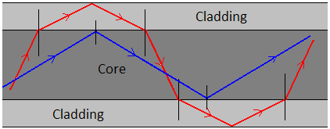
Cladding is added to the outside of an optical fibre to reduce the amount of light that is lost. It does this by giving the light rays a second chance at TIR as seen in the diagram.
It does increase the critical angle but the shortest path through the optical fibre is straight through, so only letting light which stays in the core means the signal is transmitted quicker.
Consider the optical fibre with a refractive index of 1.5…
Without cladding n₂ = 1 $\text{sin}θ_{C}=\frac{n_{2}}{n_{1}}$ $\text{sin}θ_{C}=\frac{1}{1\text{.}5}$ $θ_{C}=\text{41}\text{.}8°$
With cladding n₂ = 1.4 $\text{sin}θ_{C}=\frac{n_{2}}{n_{1}}$ $\text{sin}θ_{C}=\frac{1\text{.}4}{1\text{.}5}$ $θ_{C}=\text{69}\text{.}0°$
If the cladding had a lower refractive index than the core it is easier for light to travel through so the light would bend away from the normal, Total Internal Reflection.
If the cladding had a higher refractive index than the core it is harder for light to travel through so the light would bend towards the normal, Refraction.
Unit 2 | Interference
Lesson 20
Learning Outcomes | To be able to explain what interference and coherence is
Learning Outcomes | To be able to explain Young’s double slit experiment and a double source experiment
Learning Outcomes | To be able to use the equation to describe the appearance of fringes produced | N. DWYER

Interference
Interference is a special case of superposition where the waves that combine are coherent. The waves overlap and form a repeating interference pattern of maxima and minima areas. If the waves weren’t coherent the interference pattern would change rapidly and continuously.
Coherence: Waves which are of the same frequency, wavelength, polarisation and amplitude and in a constant phase relationship. A laser is a coherent source but a light bulb is not.
Constructive Interference: The path difference between the waves is a whole number of wavelengths so the waves arrive in phase adding together to give a large wave. 2 peaks overlap
Destructive Interference: The path difference between the waves is a half number of wavelengths so the waves arrive out of phase cancelling out to give no wave at all. A peak and trough overlap

Young’s Double Slit Experiment
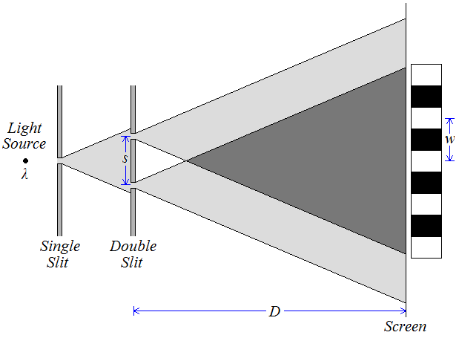
In 1803 Thomas Young settled a debate started over 100 years earlier between Newton and Huygens by demonstrating the interference of light. Newton thought that light was made up of tiny particles called corpuscles and Huygens thought that light was a wave, Young’s interference of light proves light is a wave. Here is Young’s double slit set up, the two slits act as coherent sources of waves

Interference occurs where the light from the two slits overlaps. Constructive interference produces bright areas, while deconstructive interference produces dark areas. These areas are called interference fringes.

Fringes
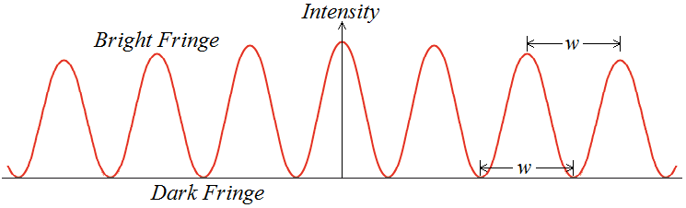
There is a central bright fringe directly behind the midpoint between the slits with more fringes evenly spaced and parallel to the slits.
As we move away from the centre of the screen we see the intensity of the bright fringes decreases.

Double Source Experiment
The interference of sound is easy to demonstrate with two speakers connected to the same signal generator. Waves of the same frequency (coherent) interfere with each other. Constructive interference produces loud fringes, while deconstructive interference produces quiet fringes.

Derivation
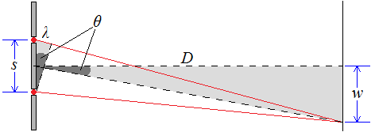
We can calculate the separation of the fringes (w) if we consider the diagram to the right which shows the first bright fringe below the central fringe. The path difference between the two waves is equal to one whole wavelength (λ) for constructive interference.
If the distance to the screen (D) is massive compared to the separation of the sources (s) the angle (θ) in the large triangle can be assumed the same as the angle in the smaller triangle.
$\text{sin}θ=\frac{\text{Opposite}}{\text{Hypotenuse}}$ For the small triangle: $\text{sin}θ=\frac{λ}{s}$ For the large triangle: $\text{sin}θ=\frac{w}{D}$
Since the angles are the same we can write $\frac{w}{D}=\text{sin}θ=\frac{λ}{s}$ or $\frac{w}{D}=\frac{λ}{s}$ which rearranges to: $w=\frac{λD}{s}$
Fringe Separation, Source Separation, Distance to Screen and Wavelength are measured in metres, m
Unit 2 | Diffraction
Lesson 21
Learning Outcomes | To know what diffraction is and when it happens the most
Learning Outcomes | To be able to sketch the diffraction pattern from a single slit and a diffraction grating
Learning Outcomes | To be able to derive dsinθ=nλ | N. DWYER

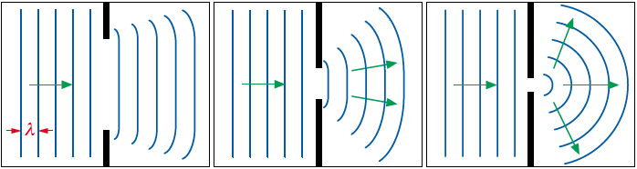
Diffraction
When waves pass through a gap they spread out, this is called diffraction. The amount of diffraction depends on the size of the wavelength compared to the size of the gap.
In the first diagram the gap is several times wider than the wavelength so the wave only spreads out a little.
In the second diagram the gap is closer to the wavelength so it begins to spread out more.
In the third diagram the gap is now roughly the same size as the wavelength so it spreads out the most.
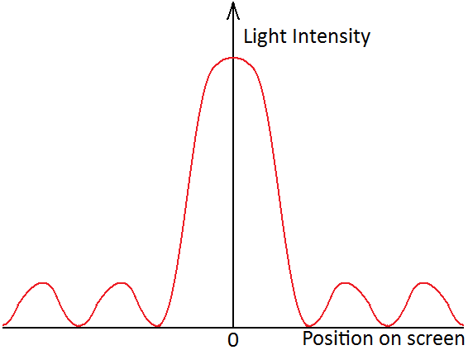

Diffraction Patterns
Here is the diffraction pattern from light being shone through a single slit. There is a central maximum that is twice as wide as the others and by far the brightest. The outer fringes are dimmer and of equal width.
If we use three, four or more slits the interference maxima become brighter, narrower and further apart.

Diffraction Grating
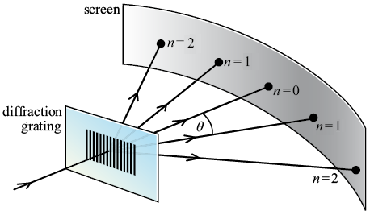
A diffraction grating is a series of narrow, parallel slits. They usually have around 500 slits per mm.
When light shines on the diffraction grating several bright sharp lines can be seen as shown in the diagram to the right.
The first bright line (or interference maximum) lies directly behind where the light shines on the grating. We call this the zero-order maximum. At an angle of θ from this lies the next bright line called the first-order maximum and so forth.
The zero-order maximum (n=0)
There is no path difference between neighbouring waves. They arrive in phase and interfere constructively.
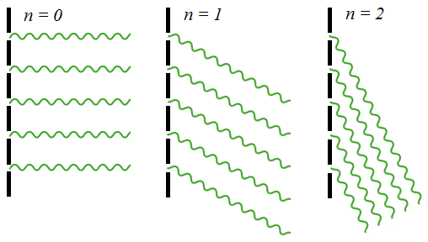
The first-order maximum (n=1)
There is a path difference of 1 wavelength between neighbouring waves. They arrive in phase and interfere constructively.
The second-order maximum (n=2)
There is a path difference of 2 wavelengths between neighbouring waves. They arrive in phase and interfere constructively.
Between the maxima
The path difference is not a whole number of wavelengths so the waves arrive out of phase and interfere destructively.

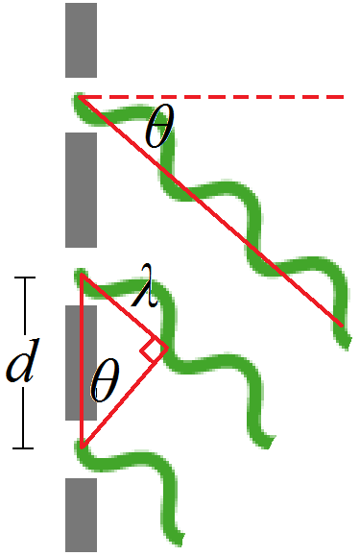
Derivation
The angle to the maxima depends on the wavelength of the light and the separation of the slits. We can derive an equation that links them by taking a closer look at two neighbouring waves going to the first-order maximum.
The distance to the screen is so much bigger than the distance between two slits that emerging waves appear to be parallel and can be treated that way.
Consider the triangle to the right.
$\text{sin}θ=\frac{\text{Opposite}}{\text{Hypotenuse}}$ → $\text{sin}θ=\frac{λ}{d}$ → $d\text{sin}θ=λ$
For the nth order the opposite side of the triangle becomes nλ, making the equation:
$$d\text{sin}θ=nλ$$

